Part 2: Individual Progress Report (each member complete one form)
Name of the Member: Ian Simmons
Report Date: 10/21/2024
List the following:
- All tasks completed the week before the past week (completion date in parenthesis). This is copied from the last report, and if this report is the first one, skip.
- All tasks completed the past week (completion date in parenthesis)
- All tasks you are currently working on or planned for this coming week (completion date in parenthesis)
For each task you have completed before the past week:
- Week 8, Task 1 (10/14)
  - N/A

- Week 8, Task 2 (10/14)
  - N/A
For each task you have completed during the past week:
- Week 9, Task 1 (10/21)
  - Over this past week the dog is now able to successfully connect to Wifi. This is done using the Network Manager application on the Raspberry Pi. This will allow us to connect to the school’s (or any other) SSID.
  - The motors are halfway disrupted still and can’t operate fully because of the way the robot’s internal network operates it may be possible

- Week 9, Task 2 (10/21)
  - N/A
For each task you are currently working on or plan to work on in the next period:
- Week 10, Task 1 (10/28)
  - The raspberry pi uses a SoC (System on Chip) design so the GPU and CPU are integrated together, currently looking for ways to maximize CPU and GPU usage for our YOLO model
- Week 10, Task 2 (10/28)
  - Although we can run our model on the head nano, there is no way to do it from a local machine as yet, one of the next steps is to incorporate code in order to utilize the image transmission over UDP. This may also speed up our YOLO model

Part 2: Individual Progress Report (each member complete one form)
Name of the Member: Ian Simmons
Report Date: 9/30/2024
List the following:
- All tasks completed the week before the past week (completion date in parenthesis). This is copied from the last report, and if this report is the first one, skip.
- All tasks completed the past week (completion date in parenthesis)
- All tasks you are currently working on or planned for this coming week (completion date in parenthesis)
For each task you have completed before the past week:
- Week 5, Task 1 (9/23)
  - E

- Week 5, Task 2 (9/23)
  - F
For each task you have completed during the past week:
- Week 6, Task 1 (9/30)

- Week 6, Task 2 (9/30)
  - C
For each task you are currently working on or plan to work on in the next period:
- Week 7, Task 1 (10/7)

- Week 7, Task 2 (10/7)

Name of the Member: Ian Simmons
Report Date: 9/23/2024
List the following:
- All tasks completed the week before the past week (completion date in parenthesis). This is copied from the last report, and if this report is the first one, skip.
- All tasks completed the past week (completion date in parenthesis)
- All tasks you are currently working on or planned for this coming week (completion date in parenthesis)
For each task you have completed before the past week:
- Week 4, Task 1 (9/16)
  - Explore files within robot for usability in network access
    - It has been noted that there is a way to give access to the robot and it is possible that it is located within one of the directories within storage.
    - If found this may be a great start to setting up networking capability

- Week 4, Task 2 (9/16)
  - Find/Register Mac address to local network
    - This is another method that is an option for giving network access to the robot
    - The significance of having network capability is for us to be able to download repositories directly to the robot as the program is running. This will greatly speed up the time needed for computing operations

For each task you have completed during the past week:
- Week 5, Task 1 (9/23)
  - This next week my focus is on completing the process of accessing the cameras through through the CameraSDK. And building the environment necessary on the Raspberry Pi

- Week 5, Task 2 (9/23)
  - Currently I am downloading the files and directories needed to stream the camera process to the local computer
  - The issue is that these directories are all incorporated and are likely to run into small errors during execution]
For each task you are currently working on or plan to work on in the next period:
- Week 6, Task 1 (9/30)

- Week 6, Task 2 (9/30)

Report Date: 9/16/2024
List the following:
- All tasks completed the week before the past week (completion date in parenthesis). This is copied from the last report, and if this report is the first one, skip.
- All tasks completed the past week (completion date in parenthesis)
- All tasks you are currently working on or planned for this coming week (completion date in parenthesis)
For each task you have completed before the past week:
- Week 3, Task 1 (9/9)
  - Research ways of adding Wi-Fi to robot
    - Access the Pi’s config directly
    - We were able to access the config settings of the Raspberry Pi and add the university network. However this did not give us internet access

- Week 3, Task 2 (9/9)
  - Connect to RaspberryPi and explore directories
    - The goal of this is to familiarize ourselves with the procedure for navigating through the libraries stored on the robot whilst practicing Linux commands at the same time. This is the main way to navigate the robots on board system to locate points of interest as well as introducing our own software/code
    - Located a directory called UnitreeCameraSDK and this appears to have a way of generating live feed from the camera in some way. Will be continuing down this direction
For each task you have completed during the past week:
- Week 4, Task 1 (9/16)
  - Explore files within robot for usability in network access
    - It has been noted that there is a way to give access to the robot and it is possible that it is located within one of the directories within storage.
    - If found this may be a great start to setting up networking capability

- Week 4, Task 2 (9/16)
  - Find/Register Mac address to local network
    - This is another method that is an option for giving network access to the robot
    - The significance of having network capability is for us to be able to download repositories directly to the robot as the program is running. This will greatly speed up the time needed for computing operations

- Week 5, Task 1 (9/23)
  - This next week my focus is on completing the process of accessing the cameras through through the CameraSDK. And building the environment necessary on the Raspberry Pi.

- Week 5, Task 2 (9/23)
  - Currently I am downloading the files and directories needed to stream the camera process to the local computer
  - The issue is that these directories are all incorporated and are likely to run into small errors during execution

Report Date: 9/9/2024
List the following:
- All tasks completed the week before the past week (completion date in parenthesis). This is copied from the last report, and if this report is the first one, skip.
- All tasks completed the past week (completion date in parenthesis)
- All tasks you are currently working on or planned for this coming week (completion date in parenthesis)
For each task you have completed before the past week:
- Week 2, Task 1 (9/2)
  - Research different nanos on Go1 as well as RaspberryPi
    - This task consisted of understanding what we were using to run our tests as well as filtering out any unnecessary information for this project
    - It is determined that we are using nano1 for the front camera

- Week 2, Task 2 (9/2)
  - Research a way to run YOLO on other brand of GPU for personal testing
    - Primarily Yolo incorporates NVIDIA graphics cards as their form of processing not everyone has this available
    - For this specific project using code that uses recognizes other graphics cards, specifically AMD was found to not be suitable for this project,
For each task you have completed during the past week:
- Week 3, Task 1 (9/9)
  - Research ways of adding Wi-Fi to robot
    - One of the key issues is the inability for the dog itself to maintain access to the network wirelessly. There is no current direct approach however there does exist an adapter for this process. One option is to access the Pi’s config directly
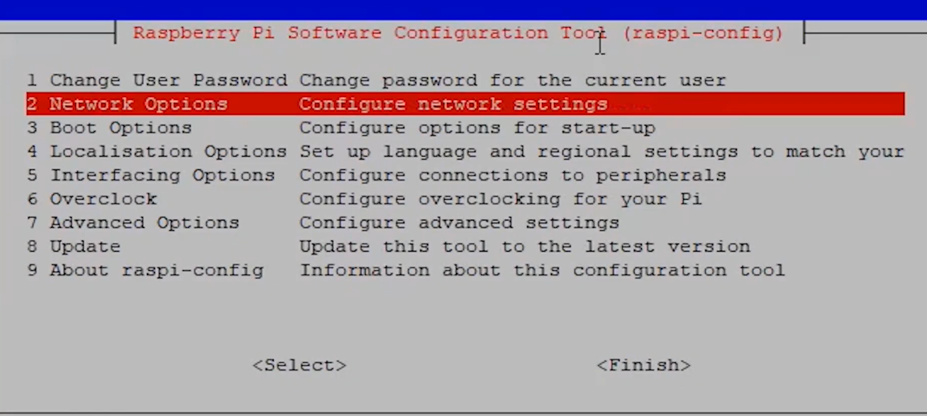
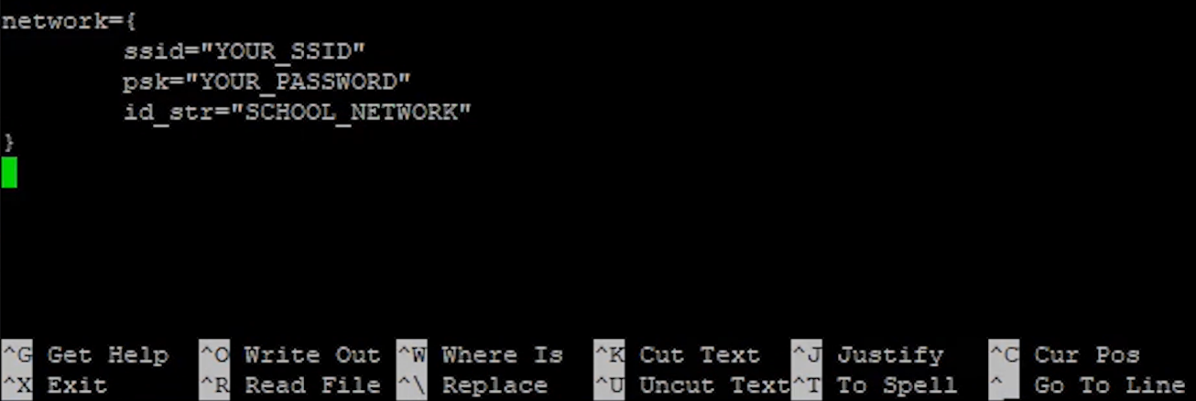

- Week 3, Task 2 (9/9)
  - Connect to RaspberryPi and explore directories
    - The goal of this is to familiarize ourselves with the procedure for navigating through the libraries stored on the robot whilst practicing Linux commands at the same time. This is the main way to navigate the robots on board system to locate points of interest as well as introducing our own software/code
    - 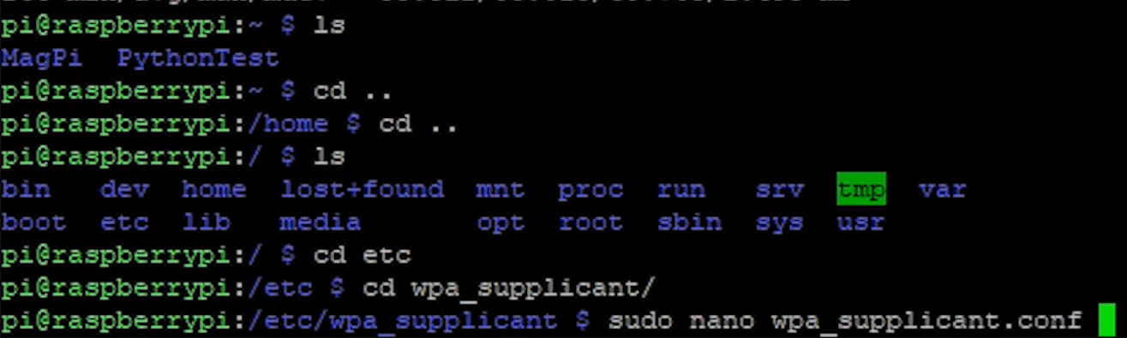

For each task you are currently working on or plan to work on in the next period:
- Week 4, Task 1 (9/16)
  - Explore files within robot for usability in network access
    - It has been noted that there is a way to give access to the robot and it is possible that it is located within one of the directories within storage.
    - If found this may be a great start to setting up networking capability
- Week 4, Task 2 (9/16)
  - Find/Register Mac address to local network
    - This is another method that is an option for giving network access to the robot
    - The significance of having network capability is for us to be able to download repositories directly to the robot as the program is running. This will greatly speed up the time needed for computing operations

Report Date: 9/2/2024
List the following:
- All tasks completed the week before the past week (completion date in parenthesis). This is copied from the last report, and if this report is the first one, skip.
- All tasks completed the past week (completion date in parenthesis)
- All tasks you are currently working on or planned for this coming week (completion date in parenthesis)
For each task you have completed before the past week:

For each task you have completed during the past week

- Week 1, Task 1 (9/2)
  - S
    - A
For each task you are currently working on or plan to work on in the next period:
- Week 3, Task 1 (9/9)
  - Research ways of adding Wi-Fi to robot
    - There are a few different ways to incorporate Wi-Fi capabilities on the robot the fastest method for running our program involves downloading repositories
    - Figuring this out will allow our robot to become operational a lot faster
- Week 3, Task 1 (9/9)
  - Connect to RaspberryPi and explore directories
    - We need to understand how to issue commands with Linux OS as well as understand where our program is going and what we need to access
    - Having the program in the right place is crucial to smooth operation and fewer errors

Report Date: 8/30/2024
List the following:
- All tasks completed the week before the past week (completion date in parenthesis). This is copied from the last report, and if this report is the first one, skip.
- All tasks completed the past week (completion date in parenthesis)
- All tasks you are currently working on or planned for this coming week (completion date in parenthesis)
For each task you have completed during the past week:
- Week 1, Task 1 (8/30)
  - Set up Teams structure and map out beginning steps
    - Add tasks bar and begin to populate, add files and folders for organization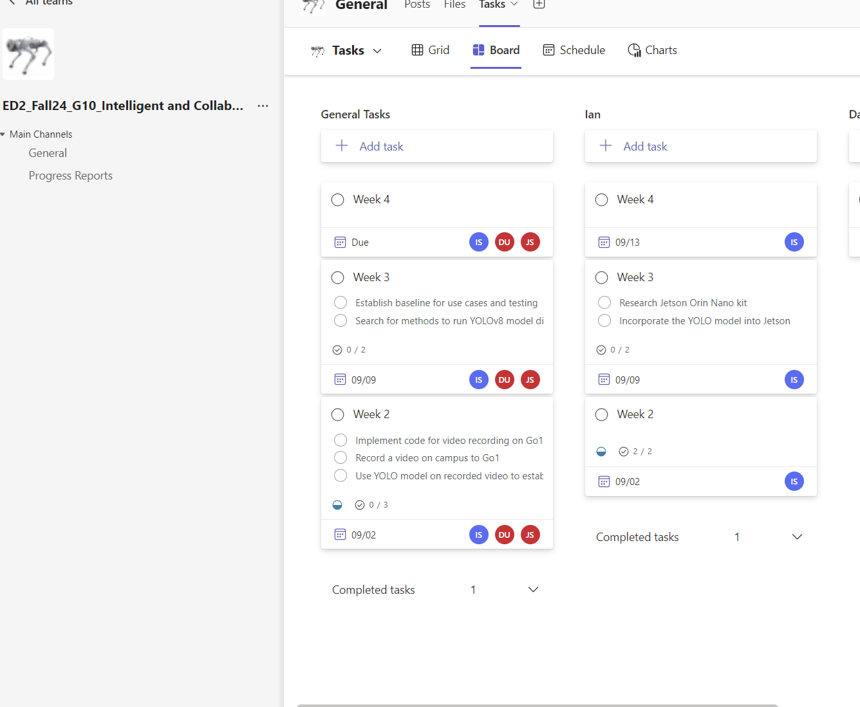

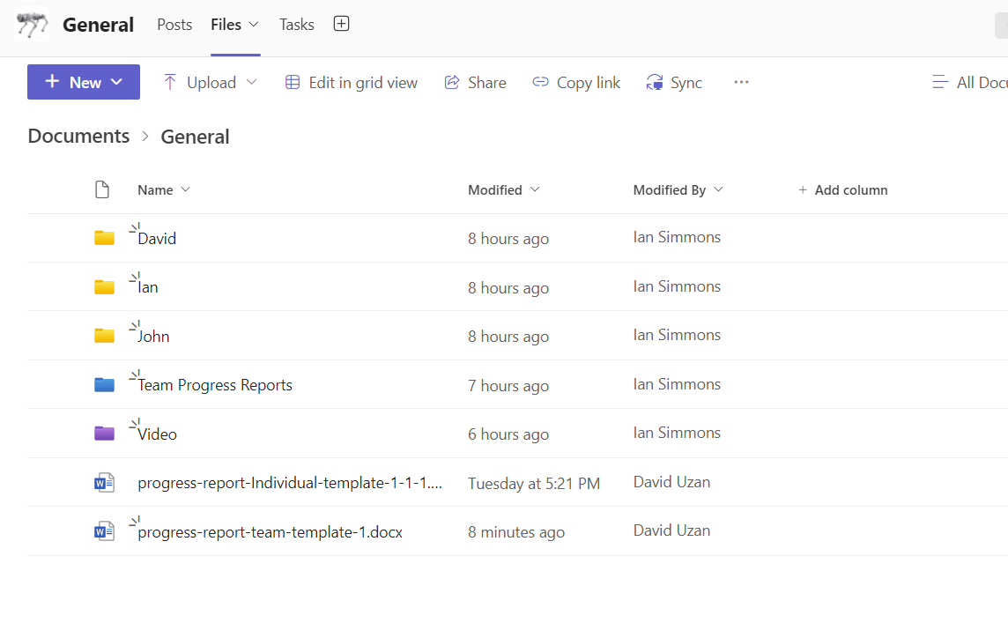
  - This will help us stay organized and on track and able to delegate work more effectively. Having a way to see everyone’s overall progress will speed up the workflow and improve communication

- Week 1, Task 2 (8/30)
  - Begin working on YOLO model on Google Colab
    - Originally, the goal was to use Visual Studio Code to incorporate the YOLO model
      - There are some personal issues that need to be ironed out, Some libraries are not being loaded and it seems as though. The v8 model only natively supports NVIDIA GPUs.
    - Google Colab Is a great way to test out these libraries with minimal errors however, There is a limit to the amount of processing power we can expect to have on Google colab.
For each task you are currently working on or plan to work on in the next period:
- Week 2, Task 1
- Short description
  - Plans, resources needed, implementation, results
  - Main challenges, reasons for any delay in completion
- Outcome of the task activity
  - Include screen shots, link to videos, plots, data tables, designs, figures, etc. as evidence of your work on the task

